Journal homepage: https://content.sciendo.com

Template for Online Journal - Measurement Science Review, Instructions for Authors
Forename Surname^{1*}, Forename Surname², Forename Surname^{2,1}
¹Department of, Faculty, University, address street, No., ZIP, City, Country, author1@institution.edu
²Institute of, Department of, address street, No., ZIP, City, Country, author2@institution.edu, author3@institution.edu
Abstract: These instructions provide guidelines for preparing papers for the MEASUREMENT SCIENCE REVIEW (MSR) online journal. Use this document as a template if you are using Microsoft Word (.docx). Note that you should format your paper using the predefined styles (starting with “m_...”) prepared in this template. The body of the manuscript should be limited to 10 pages and preceded by an Abstract limited to about 10 lines, followed by up to 6 keywords. The abstract will also be published in the appropriate PAPER SECTION of the journal together with authors’ names and the paper title. Do not cite references in the abstract. The abstract should briefly summarize the content of the paper and address the following points: briefly state the problem or issue addressed; provide a brief summary of the results and findings; and give brief concluding remarks on the study outcomes.
Keywords: List up to 6 keywords, e.g. Magnetic measurement, imaging, magnetic susceptibility, calculation, microwave frequencies.

- Introduction
Submissions to the journal Measurement Science Review (MSR) should be organized in the following sections: Introduction, Subject & Methods, Results, Discussion, Conclusion, Appendix, Acknowledgment and References.
The topic of the article should be defined CLEARLY and a short review of existing solutions and a comparison with the author’s results should be given.
- Subject & methods
Main ideas, theory, mathematical formulations should be provided, including the data on the measuring method and instruments as well as experimental results. This part should be accompanied by specific references.
- Results
Results should be briefly summarized and authors’ main scientific contributions should be demonstrated.
- Discussion
Discussion, if needed, must appear before the Conclusion.
- Guidelines for manuscript preparation
This section gives you guidelines for preparing papers for MSR.
If your paper does not conform to the required format, you will be asked to fix it.
  - Selecting a template
This document is a Microsoft Word template for MSR. The template is used to format your paper and style the text. You must use this document as both an instruction set and as a template into which you type your own text.
First, confirm that you have the correct template. Do not reuse your past papers as a template, even if your past papers conformed to the required format. To prepare your paper for submission, always download the most recent copy of this template from the journal website and read the format instructions in this template before you use it for your paper.
  - Abbreviations and acronyms
Define abbreviations, symbols and acronyms the first time they are used in the text, even after they have already been defined in the abstract.
  - Page setup and styles
The paper should be prepared in A4 format (210 x 297 mm). All margins and column widths are built-in in the template; do not alter them.
Please use the predefined styles (starting with “m_...”) shown in Table 1 to format your paper.

Table 1. Main predefined styles in WORD template.
Style name | To format | Size [pt]
m_Title | Title | 18
m_Authors | Authors‘ names | 12
m_Affiliation | Affiliation | 10
m_Abstract | Abstract | 9
m_Keywords | Keywords | 9
m_Heading1 | 1st level heading, numbered 1. 2. 3. ... | 10
m_Heading1NoNumber | Heading for APPENDIX, ACKNOWLEDGMENT, REFERENCES | 10
m_Heading2 | 2nd level heading, numbered A. B. C. ... | 10
m_Heading3 | 3rd level heading | 10
m_Text | Main text | 10
m_TextNoIndent | Text without indent – to define parameters in equations | 10
m_TextInTable | Text in tables | 10
m_List_Bullets | Bulleted list | 10
m_List_123 | Numbered list 1. 2. 3. ... | 10
m_List_abc | Numbered list a. b. c. ... | 10
m_List_iii | Numbered list i. ii. iii. ... | 10
m_References | References | 10
m_Equation | Equation | 10
m_CaptionFigure_SingleLine | Caption for figures – single line | 9
m_CaptionFigure_MultiLines | Caption for figures – multi lines | 9
m_CaptionTable_SingleLine | Caption for tables – single line | 9
m_CaptionTable_MultiLines | Caption for tables – multi lines | 9
m_Table | Style for tables | 10

You can type over sections of the template or copy and paste from another document. Highlight a section that you want to designate with a certain style, then select the appropriate name on the style menu (Home > Styles). The style will adjust your fonts, line spacing, etc. Do not change any font or paragraph settings.
The styles “m_Title”, “m_Authors”, “m_Affiliation”, “m_Abtract”, and m_Keywords” are prepared for the introductory paragraphs of the paper.
Use style “m_Text” for the main text and styles “m_List…” for bulleted or numbered lists in the paper.
  - Identify the headings
Two levels of headings should be used (styles “m_Heading1” and “m_Heading2”). When the heading styles are used, section numbers are not required to be typed in because they will be automatically numbered by the predefined multilevel list. If necessary, you can use the 3rd level not numbered heading (style “m_Heading3”).
  - Figures and tables
You should place the figures and tables in appropriate locations within the manuscript after they are cited in the text. Large figures and tables may span both columns, see Fig. 2 and Table 1. Center figures and tables in a given column. Set the figure layout to “In line with text”.
All figures and tables must be numbered using Arabic numerals, consecutively in the order they appear in your paper. Figures have their own sequence of numbers starting from Fig. 1. Tables have their own sequence of numbers starting from Table 1.
References made in the text should use this number (as shown in Fig. 1, Fig. 3(a), Table 1, etc.). Use the abbreviation “Fig. 1”, even at the beginning of a sentence. Do not abbreviate “Table”. Use multiple references according to the following examples:
- Fig. 1, Fig. 4(b), Table 1, Table 3,
- Fig. 1 and Fig. 3,
- Fig. 2 to Fig. 4 or Fig. 2 – Fig. 4,
- Table 2 to Table 4 or Table 2 – Table 4.
Place figure captions below the figures; place table captions above the tables. Single-line captions must be centered, see Table 1. Multi-line captions must be justified, see Fig. 1 and Table 2. Use the predefined styles (“m_Caption…”) for captions.
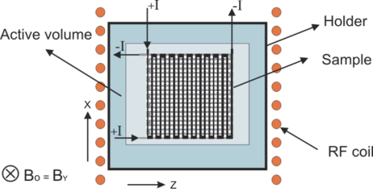
Fig. 1. The designed structure based on ABC technology, very useful for applications in industrial measurements.
Subfigures in multipart figures should be inserted separately or as one figure. Please do not put any figures or subfigures in tables. The subfigure labels should appear centered below each subfigure in the format of (a), (b), (c), see Fig. 2 and Fig. 3.

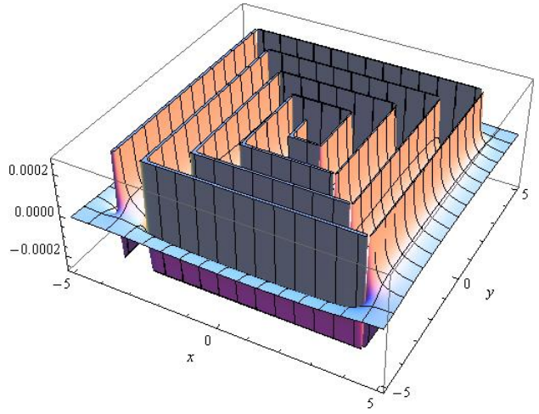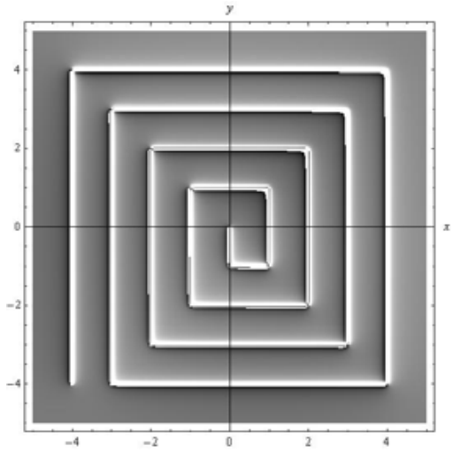
(a) (b)
Fig. 2. (a) Calculated magnetic field Hz (x, y) of the planar meander rectangular coil, limited plot-range, 3D-plot of relative values,
(b) Calculated magnetic field Hz (x, y) of the planar meander rectangular coil. Density-plot of relative values – similar to NMR image.

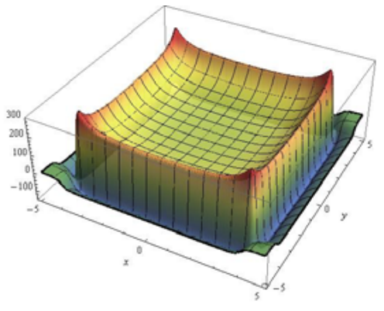
(a)
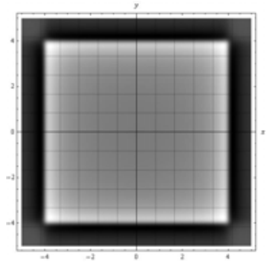
(b)
Fig. 3. Computation result – magnetic field Hz (x, y, z),
(a) 3D Plot of the simple rectangular coil according to Fig. 4.
(b) Density-plot of relative values of the magnetic field Hz (x, y, z).
Please do not put any text in “text boxes” linked to the figures. The texts in the figure must be part of the figure, see Fig. 1. Make sure that each figure is only one object, not composed of several objects.
You should use the style “m_TextInTable” for text in tables. You can align decimal numbers in tables – select decimal tab at the left edge of your vertical ruler, select cells in the column and click on your ruler above the column at the location where you want your numbers aligned (see the 3rd column in Table 1). You can center number ranges in tables (see the 2nd and 3rd columns in Table 2).
Please do not put borders around the outside of your figures. Use only top and bottom borders for your tables and header rows, see Table 1 and Table 2.
Table 2. Chemical bonds associated with biological processes and their approximate energies.
Bond | Energy  [kJ/mol] | Energy export x10⁻¹⁹  [J]
Ionic | ~ 700 | 11.6
Covalent IV | 1100 - 1300 | 15.5 - 17.8
Covalent III | 800 - 1000 | 13.3 - 16.6
Covalent II | 500 - 700 | 8.3 - 16.6
Covalent I | 300 - 500 | 4.9 - 8.3

  - Equations
Use the built-in Equation Editor in MS Word for equations in your paper (Insert > Equation > Insert New Equation).
To use the predefined style for equations, first select the „m_Equation“ style, then press the tab key, then use the equation editor to create the equation. Finally, press the tab key and write the equation number in parentheses.
Fit the longer equation into one column by breaking it as you wish it to appear when typeset. You may find it convenient to create a new “equation” for each section of the equation.
Number equations consecutively with equation numbers in parentheses flush with the right margin, as in (1).
$\frac{f_{os}}{2^{L}}=f_{s}>2f_{max }⟹E_{kv} = \frac{Q}{\sqrt{12}\sqrt{2^{L}}}$ (1)
where Q … and L …
Ensure that the symbols in your equation have been defined before the equation appears or immediately following it. Refer to „(1)“, not „Eq. (1)“ nor „equation (1)“, except at the beginning of a sentence: „Equation (1) is ... .“
  - Programs and codes
If necessary, include parts or entire texts of your programs following the “m_Codes” style using the “New Courier” font with caption “m_CaptionCode”, see Code 1.
Code 1. Source code caption.
void main(void)
{ WDTCTL = WDTPW + WDTHOLD; //Stop watchdog
P3DIR |= 0x01; //P3.0 - output
for (;;)
{ unsigned int i; i = 50000;
do i--;
while (i != 0); //SW Delay
P3OUT ^= 0xFF; //Toggle P3.0
}
}
Try to fit your code texts in one column. Wide programs may span across both columns. If so, place them at the top or bottom of the corresponding page.
Use only top and bottom borders for your code. Place code captions with numbering above the frame.
  - Units
Please note the following points:
- Use either SI (MKS) or CGS as primary units. (SI units are encouraged.)
- Use a zero before decimal points: “0.75”, not “.75”.
- Use an unbreakable space between number and unit (press Ctrl + Shift + Spacebar) to keep them from separating at line breaks: “2 cm”, not “2 cm” (press Home > Paragraph > Show/Hide paragraph marks… to see the difference).
  - References
See the end of this document for formats and examples of common reference types: journal article [1], book [2], book chapter [3], conference proceedings article [4], thesis [5], report/ patent [6], standard [7], online web page [8].
If you use reference manager, you can use citation style of “American Journal of Climate Change”.
Each source you cite in the paper must appear in your reference list; likewise, each entry in the reference list must be cited in your text. Please verify that items in the reference list are not duplicated. Before submitting your paper, please ensure you have checked your paper for any relevant references you may have missed.
Please pay attention to spelling, capitalization and punctuation. Accuracy and completeness of references are the responsibilities of the author.
Number citations consecutively in square brackets [1]. When citing a section in a book, please give the relevant page numbers [1]. In sentences, refer simply to the reference number, as in [3]. Do not use „Ref. [3]” nor „reference [3]” except at the beginning of a sentence: „Reference [3] shows …”. Multiple references are each numbered with separate brackets (e.g. [2], [3], [7], [1]-[3]). The sentence punctuation follows the brackets [2].
- Editorial policy
At least two favorable reviews are required for a paper to be accepted for publication.
- For regular papers, the editors additionally determine suitability, which is different from a judgment of whether the paper is sound or flawed.
- The editors consider whether the paper contributes significant new material, is within the scope of the journal or is more suited to another journal.
- Unreadable English is a valid reason for rejection.
- Authors of rejected papers may revise and resubmit them to the MSR as regular papers, whereupon they will be reviewed by two new referees.
- Publication principles
MSR is a peer-reviewed, archival journal in science and technology related to the theory of measurement, measurement of physical quantities and measurement in biomedicine.
The paper must have a character of a basic scientific research paper in the “Measurement Science” field, (new theory, analysis, synthesis, modelling, new measurement method, new sensors, data processing, data interpretation, graphical evaluation, new results, etc.).
Authors should consider the following points:
- Technical papers submitted for publication must advance the state of knowledge and must cite relevant prior work.
- The length of the submitted paper is limited to a maxi-mum of 10 pages and should be commensurate with the importance of the work and appropriate to its complexity.
- Abstract is limited to 10 lines.
- Authors must convince both peer reviewers and the editors of the scientific and technical merit of the paper; the quality of evidence is higher when extraordinary or unexpected results are reported.
- Papers are published proportionally to the chronological sequence and according to the scientific quality of papers.
- Conclusion
A conclusion section is required. It presents a critical analysis, interpretation and evaluation of the obtained results.
Conclusion may review the main points of the paper but do not replicate the abstract in the conclusion. Conclusion might elaborate on the major findings and importance of the work or suggest applications and extensions.
Appendix
Appendixes, if needed, must appear before the Acknowledgment.
Acknowledgment
Use the singular heading even if you have many acknowledgments.
References
- Stein, G. J., Chmurny, R., Rosik, V. (2011). Compact vibration measuring system for in-vehicle applications. Measurement Science Review, 11 (5), 154-159. https://doi.org/10.2478/v10048-011-0030-1
- Kleiner, F. S., Mamiya, C. J., Tansey, R. G. (2001). Gardner’s Art Through the Ages (11th ed.). Harcourt College Publishers, ISBN 9780534167035. (ISBN or DOI link at the end of reference like https://doi.org/10.1109/5.771073).
- Roll, W. P. (1976). ESP and memory. In Philosophical Dimensions of Parapsychology. American Psychiatric Press, 154-184. ISBN 9780534167035. (ISBN or DOI link at the end of reference).
- Field, G. (2001). Rethinking reference rethought. In Revelling in Reference: Reference and Information Services Section Symposium. Australian Library and Information Association, 46-52.
https://doi.org/10.1109/5.771073
- Begg, M. M. (2001). Dairy farm women in the Waikato 1946-1996: Fifty years of social and structural change. Doctoral dissertation, University of Waikato, Hamilton, New Zealand.
- Osgood, D. W., Wilson, J. K. (1990). Covariation of adolescent health problems. NTIS No. PB 91-154 377/AS, University of Nebraska, Lincoln, US.
- ISO (2008). Uncertainty of measurement - Part 3: Guide to the expression of uncertainty in measurement
(GUM:1995). ISO/IEC Guide 98-3:2008.
- Walker, J. (1996). APA-style citations of electronic resources. http://www.cas.usf.edu/english/walker/apa.html
Received January xx, 2024
Accepted xx xx, 2024

To speed up the review process, it is recommended to propose several reviewers for every submitted paper
(NOT from the country of authors).
Please place the table with reviewers on an extra last page of your paper

 | Titles, Name, Surname: | Affiliation, institute, address: | e-mail address:
1.
2.
3.
4.

or
use the form (Recommended Reviewers) when submitting your paper via Open Journal System (OJS):
https://journals.savba.sk/index.php/msr/index

